**On second thoughts ...**

On second thoughts, I think you should remove the console logs.

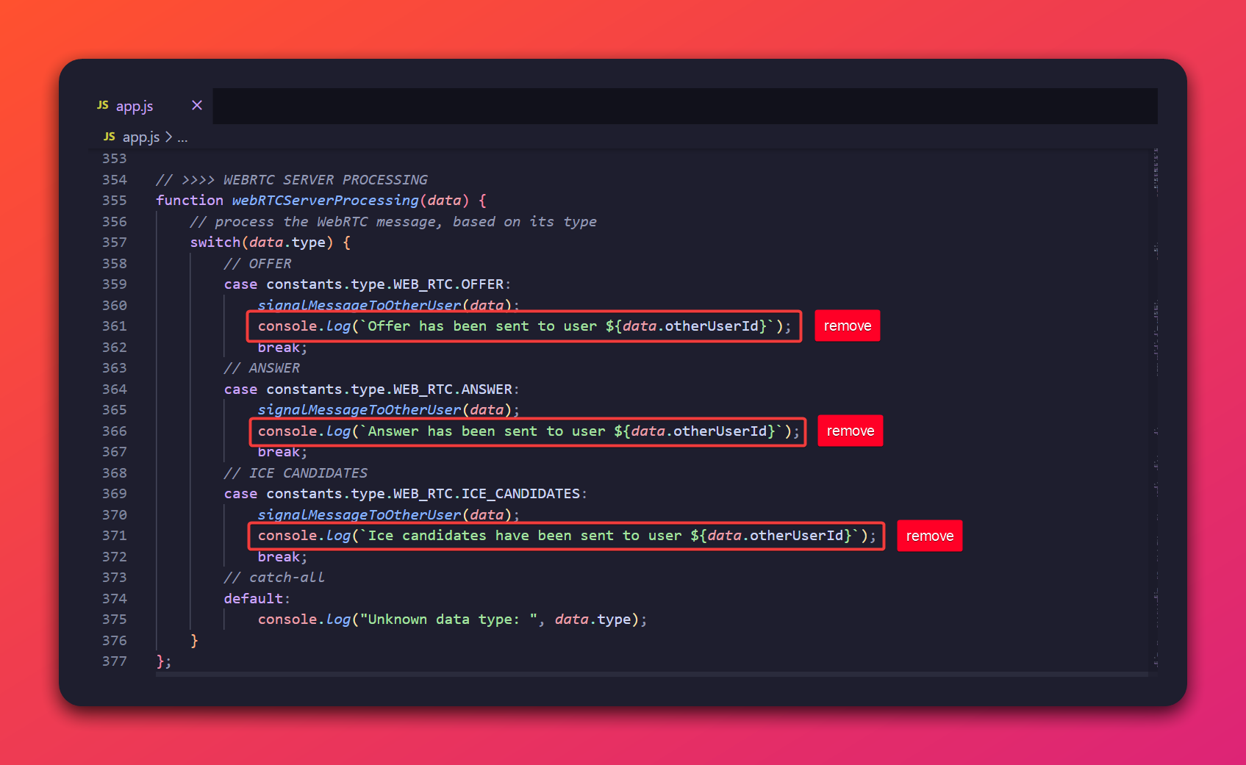

The webRTCServerProcessing function currently includes console.log statements within each case of the switch statement, after calling signalMessageToOtherUser. This can lead to inaccurate or redundant logging because the actual sending of the message and the handling of failure scenarios are managed within the signalMessageToOtherUser function, and further down in the sendWebSocketMessageToUser function.

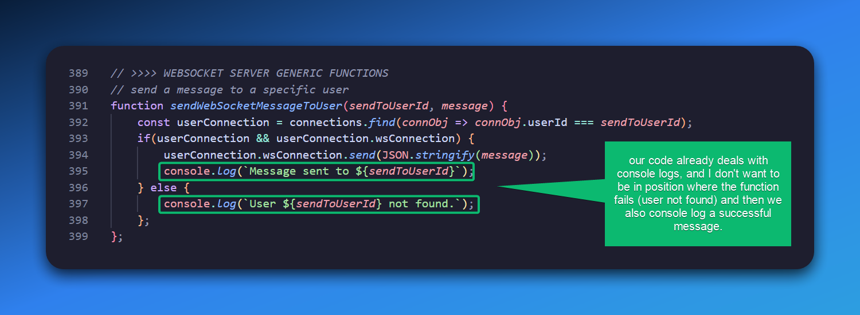

In other words, I think it'll be better like this:

function webRTCServerProcessing(data) {

// process the WebRTC message, based on its type

switch(data.type) {

// OFFER

case constants.type.WEB_RTC.OFFER:

signalMessageToOtherUser(data);

break;

// ANSWER

case constants.type.WEB_RTC.ANSWER:

signalMessageToOtherUser(data);

break;

// ICE CANDIDATES

case constants.type.WEB_RTC.ICE_CANDIDATES:

signalMessageToOtherUser(data);

break;

// catch-all

default:

console.log("Unknown data type: ", data.type);

}

};

Removing these redundant logs will result in a cleaner and more accurate console output, reducing the potential for misleading information during debugging.

While I'll leave the current logging in the code for now—as I only spotted this issue later in the process—I wanted to bring it to your attention.

*p.s: this won't break our application in any way. It only comes down to accurate console messages for debugging our code*